CURRICUL1UM-VITAE
DHARMENDERKUMAR

Address
D-765, Block-D
JahangirPuriDelhi-110033
Mobile: 8376879972
E-mail:Dharmendrahoriba@gmail.com
CARRIEROBJECTIVE:
▶ To achieve a responsible position that will allow me to utilize my skills, experience and willingness stool earn in making an organization successful.

Job Profile

Currently working with Tanvi Trading Company as an Assistant Manager Office & Sales Team Coordinator from 3rd July 2024 to April 2025.
- Managing email, phone calls, and mail; preparing reports and presentations; and maintaining files and records.
- Daily office routine work.
- Document controller
- Coordination with senior and junior staff for day to day smooth working.
- Inventory management.
- Coordination with Sales Team and their requirement etc.

▶ Worked in Zenica Pharma Medical Ind. as Administrative and Billing Executive from August 2023 to April 2024.
Zenica Pharma Medical Ind. Job Profile:
Administrator and receptionist All Multi tasking work.
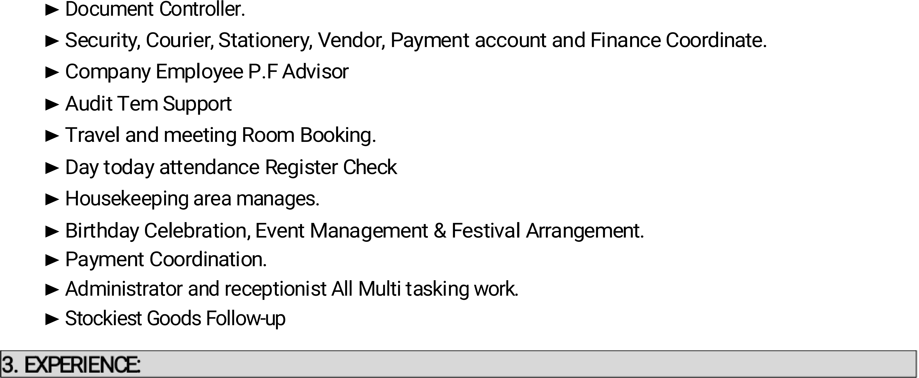
2. EXPERIENCE:
Worked in Horiba India Pvt Ltd. (Okhla Phase-3Indus Area) as Account & Office Assistant from March 2012 to April-2022.
Horiba India Pvt Ltd Job Profile:
▶
▶
▶
▶ PF Advisor:-UAN Activate, KYC Update, Pf Transfer, Pf Withdrawal,To Company Pf Advisor.
▶
▶ RunningWork:-RTGS,NEFT,DemandDraft,ChequeTransfer,ECBReturnFile&Etc
▶ Payment Detail. Remittance Payment, CHA Payment,
1. EXPERIENCE:

Bata Pvt Ltd. Job Profile:
Customer Handling
Stock Maintain
Languages known | : | Hindi & English
Marital status | : | Married
Hobbies | : | Playing Cricket, Commitment & Timing
Gender | : | Male
Stock Ordering
ACADEMICQUALIFICATION | BOARD/UNIV. | SCHOOL/COLLEGE
 |  | Janta Inter College
 |  | Janta Inter College
B.A Second Year | Meerut University | Swami Vivekanand University
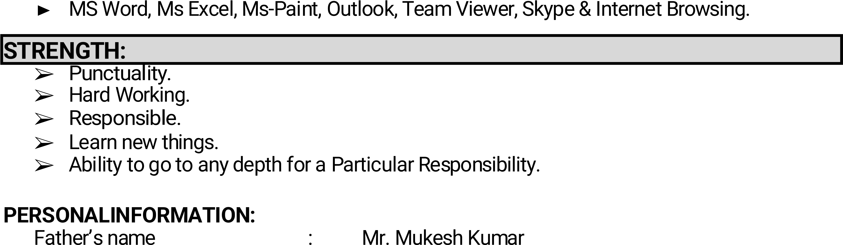
Mother’s Name | : | Smt. Girija Devi
Current Address | : | D-765 Jahangir Puri Delhi-110033
Permanent Address | : | D-765 Jahangir Puri Delhi-110033
PLACE: Delhi
3
DATE:………………. (DHARMENDER KUMAR)

